HOW POWERHOUSE VENEZUELA HAS TURNED INTO A PAUPER
Jeff Lewis
CARACAS — The Globe and Mail
Friday, Mar. 27 2015, 2:42 PM EDT
There are no bursts of colour as fireworks pop high above the Bulevar de Sabana Grande. Only thin wisps of smoke in the azure sky mark the precise time, two years ago, that Hugo Chavez died suddenly, from cancer.
It is 4:25 p.m., and Venezuelans are taking stock of an economy in meltdown.
“I don’t feel good at all,” one man grouses.
“It’s terrible. This is total chaos,” a student adds.
Even once-ardent supporters of the charismatic leader are growing restive with life under his hand-picked successor, President Nicolas Maduro.
For years, Venezuela was a nation on the rise – a founding member of the Organization of Petroleum Exporting Countries more than 50 years ago. Decades later, Mr. Chavez was able to lavish oil riches on the poorest residents, providing everything from hospital clinics to hefty food subsidies and free gasoline.
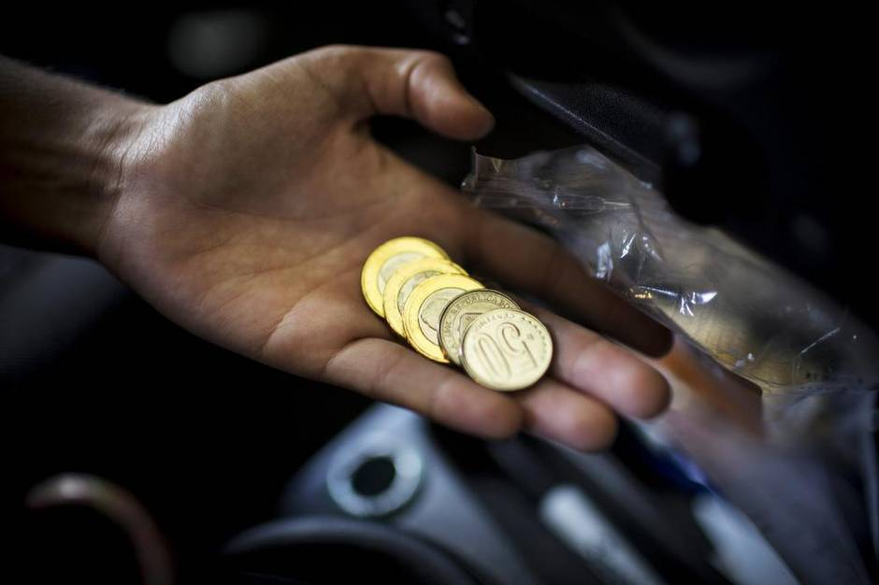
The cost of gas in Venezuela is a major source of debate. At just a few cents to fill up the tank, its the cheapest in the world, but some feel the price should be elevated to offset some of the country’s financial problems. (Natalie Keyssar for The Globe and Mail)
Today, the country is in the midst of economic and political chaos. Oil prices have fallen by more than 50 per cent since last summer, and so much crude is sloshing around in global markets that even subsidized oil from Venezuela looks relatively expensive. President Maduro is scrambling to meet billions of dollars in debt payments due this year, while struggling to quell violence and manage an increasingly disillusioned population of about 30 million. Meanwhile, Cuba is re-establishing ties with the United States, once a shared foe.
At the same time, years of central planning and rigid price controls have gutted domestic production of many goods, leaving Venezuela completely dependent on imports it can no longer afford. Shortages of food, medical supplies and other staples are widespread and getting worse. Those once-beneficent medical clinics are closing, grocery-store lineups last hours, and violent crime – already among the worst in the world – is on the upswing. The abrupt skid in oil prices and resulting unrest have rapidly transformed the former Latin American powerhouse into a pauper, undermining its regional influence. It is also further weakening a key competitor to Canada’s oil sands.
As conditions deteriorate, Mr. Maduro is lashing out in paranoid fits. In recent weeks, the government has stepped up arbitrary detentions, jailing political opponents on conspiracy charges, and business executives for allegedly hoarding supplies. The aggressive moves have cast doubt on the timing of parliamentary elections set for later this year. They have also stoked fears that Venezuela is in the twilight of an unlikely experiment in democracy. Under the sway of Mr. Maduro, there are fresh anxieties that the country is careening toward some place much darker.
‘Without national industry, we don’t eat’
Roughly 660 kilometres southeast of Caracas’s sun-baked streets, at the confluence of the Orinoco and Caroni rivers, stands Ciudad Guayana. This industrial region once lured Spanish conquistadors in search of El Dorado, the mythical city of gold. By the 1960s, though, the city served as a base for developing Venezuela’s natural riches: iron ore, bauxite, coal, hydroelectricity and oil.
By the mid-1980s, CVG Venalum, the state-run aluminum company, was bleeding cash, and its smelter, in nearby Puerto Ordaz, was running at 60-per-cent capacity. But over time the operation returned to profit, a former executive recalled. Production rebounded, and a $600-million (U.S.) expansion pushed output to new highs.
“We were at one time the 12th-largest aluminum producer in the world,” says the former employee, who asked for anonymity to avoid political repercussions.
In 1998, Venalum was on the verge of being privatized. Then, a young military lieutenant named Hugo Chavez became president. The privatization plan was abandoned, investment fled, output withered. Today, the company is a husk – yet another sign of rot in a mouldering economy.
Beginning in 2003, Venezuela reaped billions as Chinese demand began to push oil prices sharply upward. The windfall helped Mr. Chavez cut poverty and boost incomes, largely through transfers and social programs. But debt piled up, and widespread graft fostered a new class of superrich known as the “boligarchs.” (The reference is both to oligarchs and Simon Bolivar, an independence hero revered by the supporters of presidents Chavez and Maduro.)
Under Mr. Chavez, the country borrowed as much as $70-billion during a decade-long boom, and spent lavishly. According to Francisco Monaldi, a visiting professor of energy policy at Harvard University, Venezuela’s fiscal deficit stood at more than 18 per cent of GDP the year before Mr. Chavez won his last election, in 2012; government spending climbed to more than 52 per cent of GDP, and imports totalled $60-billion. Key industries atrophied from neglect or were nationalized.
“I believe that the biggest problem is that, throughout time, there’s been a policy of destroying the national industry,” says Joaquin Ortega, a political scientist at the Central University of Venezuela. “Without national industry, we don’t eat what we produce, [and] we don’t wear what we produce. Everything is imported.”
In the latest sign of neglect, the country recently started swapping oil for coffee with Nicaragua. At the same time, foreign investment has shrivelled, and a flood of cash has left the country as professionals seek hard assets in more stable locales. By one estimate, Venezuelans hold as much as $350-billion in assets offshore.
Still, Mr. Chavez retains an aura of power. His image is a potent political symbol: It salutes motorists snarled in traffic from highway billboards, urging them to stay the course:“Cumpliendo la mision!”
“They have created a lot of propaganda and fantasy around the almost magical powers that are attributed to Chavez and how he could move people,” Mr. Ortega says. But Venezuela today is marked by growing repression and financial excess for a select few, he says. The recent commodity crash, he adds, only lends fresh irony to an old saying: “The closer to the oil well, the poorer you are.”
Parallel realities
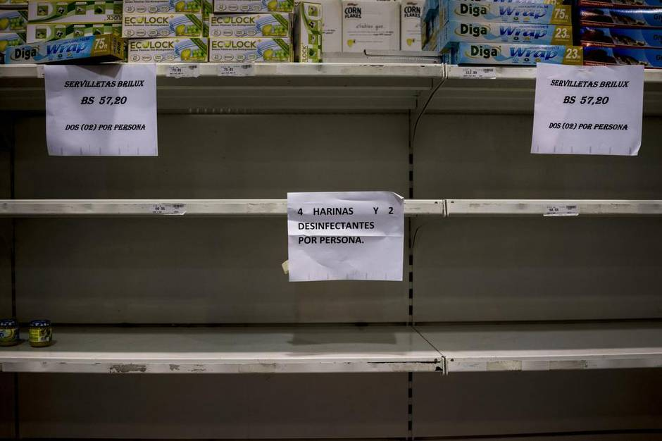
Chronic shortages of basic groceries are a reality in many parts of Venezuela. (Natalie Keyssar for The Globe and Mail)
Nicolas Maduro is opening a new grocery store. It’s Saturday in Caracas, and the city’s streets are deserted. The president, doing his best to look sporty and patriotic in a blue, yellow and red jumpsuit, is beaming into televisions and over radios across the country.
Since taking office two years ago, Mr. Maduro has aped Mr. Chavez in using state-controlled media broadcasts – known as cadenas, or “chains” – to alternately flay the opposition and tout the latest government achievement. On occasion, he wields a pocket-sized copy of the country’s constitution.
Today, he is seated at a long table flanked by key ministers. Behind him, store shelves are conspicuously full. There is cooking oil, powdered milk, cornmeal. “That’s the wealth of socialism,” he says. Moments later, a block of white cheese is lowered onto the table in front of him. “Great cheese,” he raves. “Let’s open it so you can see. This is a fresh product. Get me a knife!”
He cuts a piece and begins chewing, with gusto. Venezuela, he says, between mouthfuls, is fighting a war. “Capitalism versus socialism, humanism versus diabolical models,” he thunders. Just as quickly, his tone softens. “Here you have it, a wonderful cheese. Pass it out in the front row with a banana that’s over there. Marvellous!”
Before the broadcast cuts to a dairy farm (the source of the cheese), Mr. Maduro reflects, to no one in particular, “You know, with a little Andean bread and a hot coffee and this cheese, we can be the whole afternoon over here.”
Outside, chronic shortages and daily shop queues belie his rhetoric. In fact, some government-run grocery stores have taken to moving the long lines of waiting customers to underground parking garages – in an attempt to stop people from tweeting pictures that contradict official assurances that shortages are rare.
Fingerprint scanners, first rolled out last October, are increasingly used to enforce the rationing of basic price-controlled items, including milk, rice, coffee, toothpaste, chicken and detergent. Signs posted at some stores indicate which days people can purchase goods: Your shopping day is determined by the last digit on your national identification card.
Such policies prevent people from stocking up on particular items. Shoppers can buy just one kilogram of powdered milk a week, for example; locals say the restrictions only lengthen queues and wait times.
“I feel that people are blind. They don’t get what we’re going through,” says “Carlota,” 63, a resident of a slum called the 23rd of January (its name refers to the date of the 1958 coup d’état that overthrew dictator Marcos Perez Jimenez). One of dozens of people lining up for laundry soap in the rain one recent morning, Carlota had left her post at a government bank without permission to do so, so did not want to use her real name.
The shortages extend far beyond food and laundry detergent. Tal Cual, a daily opposition newspaper, recently fired 50 per cent of its staff and slashed its print run to once a week, due partly to shortages of newsprint, says its editor, Xabier Coscojuela.
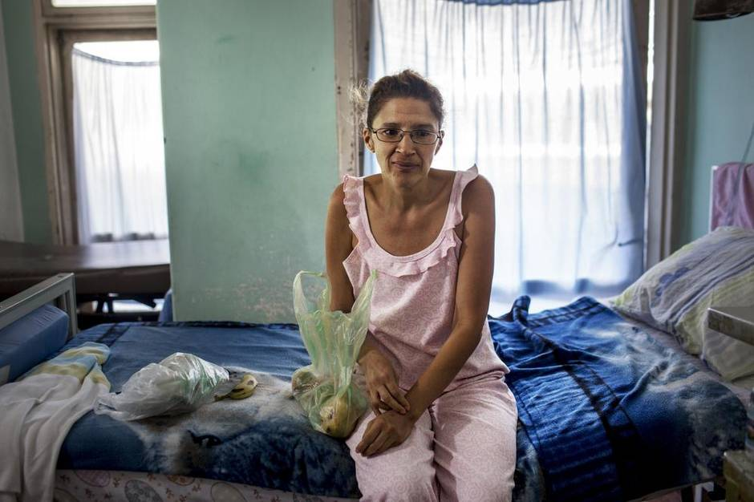
A patient holds a bag containing food and water that her sister brought her while she waits for care in a hospital in Caracas. Doctors have reported debilitating shortages of supplies – sheets, food, surgical gloves, antibiotics – needed to care for patients. (Natalie Keyssar for The Globe and Mail)
The health-care system, hailed by supporters as one of Mr. Chavez’s triumphs, is crumbling. The University Hospital in Caracas – with 1,200 beds, it is Venezuela’s largest – is grappling with shortages of key supplies. When The Globe and Mail visited earlier this month, there were no surgical gloves, medical sponges or antibiotics, and anesthetic was running out. Nor was there basic equipment needed to perform heart surgeries, according to two cardiovascular specialists there.
Amid the chaos, doctors say colleagues are decamping to Chile, Colombia, Australia, Canada, the U.S. and Spain. Those who remain say they are effectively on strike.
“Patients are dying because of the lack of supplies” and delayed procedures, says Isaubett Yajure Mendez, a third-year resident on the unit. As of mid-February, when heart surgeries stopped completely, the university hospital had performed only 15 procedures this year.
Gaming the system
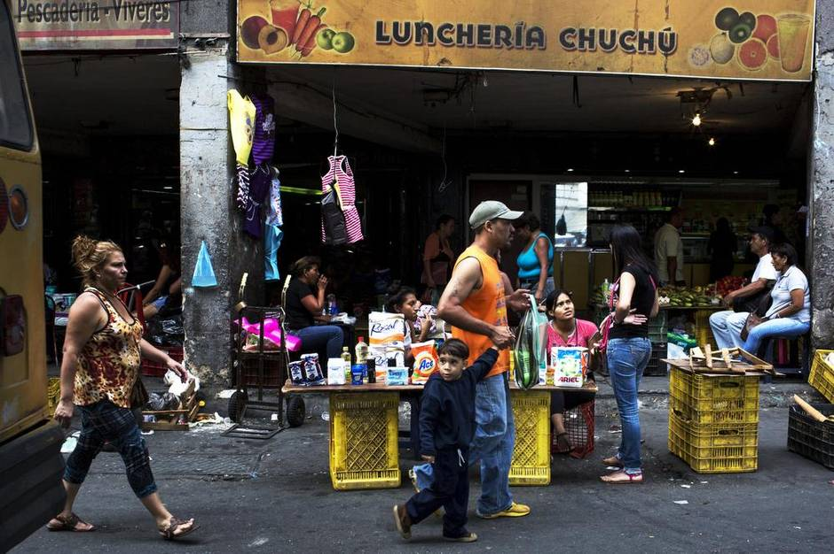
With lines for subsidized products which are in short supply lasting hours at supermarkets, street vendors often sell the products at a markup. In the vast outdoor market of Petare, vendors sell toilet paper, detergent, and other scarce supplies. (Natalie Keyssar for The Globe and Mail)
Street vendors jostle in the shadow of diesel-spewing buses outside the Petare metro station, a gateway to a slum on the capital’s outskirts. The roadside flea market unfurls in a sea of flip-flops, leather wallets, clothing and cheap jewellery.
Here, too, are the fruits of the country’s rigid currency controls. An array of products, from diapers to hand soap, fetch at least 10 times regulated rates. Three condoms cost more than does a kilogram of chicken.
Venezuela’s inflation rate has soared to roughly 70 per cent, among the world’s highest. Official rates start at 6.3 bolivars to the U.S. dollar (when, for instance the government is importing goods) but have hit up to 193 bolivars to the dollar, under a new exchange platform recently launched. The black-market rate, meanwhile, was at 280 during my visit there this month. This mess leads to massive price distortions and is causing private investment to atrophy.
It also means that vast sums can be earned by those willing to manipulate the system. Venezuela’s substantial food subsidies have fuelled smuggling with neighbouring Colombia, intensifying shortages in western cities such as Maracaibo, residents there say.
In February, Mr. Maduro’s government introduced a new exchange platform called Simadi, in a bid to combat the black market. But that so-called Marginal Currency System is far from ideal, those with knowledge of it say. Despite promises that the new rate would be free-floating, the government remains stingy in doling out U.S. dollars.
“The ideal thing to do is to not have any type of control,” says Jorge Roig, president of the Venezuelan Federation of Chambers of Commerce, which represents private businesses, during an interview at his Caracas office. “But we understand that the political reasons for that to happen are not favourable right now.”
Critics blame the complex system for squeezing profits and worsening shortages. For its part, the government accuses business owners of hoarding goods, smuggling and price gouging, as part of an “economic war” aimed at sabotaging the country. As recently as last month, two executives at a major pharmacy chain were arrested and charged with “economic destabilization.”
The currency regime has forced some businesses to take extraordinary measures. To maintain stocks of everything from milk to coffee and macadamia nuts at his Caracas café, Carlos Avila pays farmers far more than the government-controlled prices.
For cacao, he pays 550 bolivars a kilogram; that compares to the officially decreed price of 35 bolivars. Coffee is regulated at 95 bolivars a kilo; Mr. Avila pays 300. Because distributing green coffee beans is illegal, his supply trucks are regularly harassed by government soldiers seeking bribes. “The people who wrote the law are inept,” he scoffs, sitting at a small corner table in Franca Coffeecakes in Caracas’s Las Mercedes neighbourhood, one of three locations the 38-year-old owns in the city.
Years of rigid price controls and central planning ensure espresso is cheap in cities, while bleeding farmers of profit, Mr. Avila maintains. As a result, he says that many farmers have given up entirely, migrating in massive numbers from rural communities to urban barrios, exacerbating poverty.
It is a cycle that Mr. Avila knows well. In 2013, an employee’s two sons were incarcerated. A year later, one of the boys was gunned down in a gangland shooting. Their mother lived in one of the capital’s sprawling slums: Her own parents had farmed cacao but didn’t earn enough money to live, and so had moved to the city. Her son’s death marked a turning point for the company and for Mr. Avila personally, he says, now haunted by a question: What if the mother’s parents had never left the fields?
“If we shift our vision of purchasing supplies toward rural communities, there is a bigger chance, even though it’s small-scale, that we can prevent that situation,” he says over the soft clink of cutlery scraping on dishes.
He is fighting strong currents, he acknowledges: Venezuela’s economic incentives are massively distorted, and paying more than government-mandated prices isn’t always enough to keep farmers growing their agricultural crops. Two growers whom Mr. Avila recently met have swapped cacao and coffee for caco and marijuana, underscoring a stark challenge.
“If we as a nation are not willing to pay our growers for their green coffee the amount of money they would get for caco,” the entrepreneur says, “basically we’re going to have a very, very fucked-up society.”
The bottom of the oil barrel
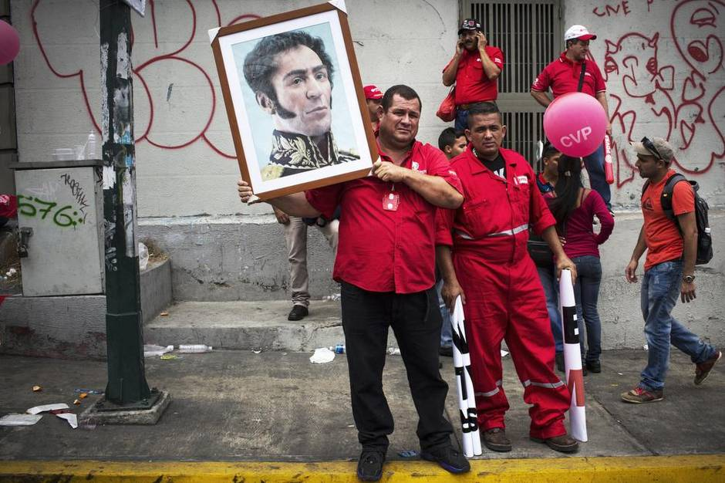
Thousands of employees and supporters of the national oil company PDVSA attended recent a rally against imperialism. (Natalie Keyssar for The Globe and Mail)
Those shortages and currency struggles are set against the sharp plunge in global oil prices. The commodity accounts for 96 per cent of Venezuelan exports, and generated some $78-billion in hard currency in 2013.
The central bank estimates a minimum oil price of $117 a barrel is needed if the country is to make ends meet; among other expenses are billions in debt payments due this year. But the price of Venezuelan oil is expected to average just $44 a barrel this year, according to economic-research firm Ecoanalitica C.A., leaving an estimated $33-billion hole in the government’s budget.
Once an industry leader, Petroleos de Venezuela S.A. (PDVSA), the nationally owned oil and natural-gas company, is now a bloated mess, says Jose Toro Hardy, who left the organization as Mr. Chavez came to power. Its mandate has spread to include sectors that have little to do with petroleum, among them social housing. “They are doing everything,” Mr. Hardy says, “but producing oil.”
The company is burdened by debt, and daily production has fallen precipitously, to about 2.6 million barrels, down from a peak of roughly 3.3 million barrels in 2005. U.S. imports of Venezuelan crude oil and petroleum products are down 49 per cent from a decade ago; they sat at about 800,000 barrels a day in 2013. Locally, President Maduro has so far balked at raising the price of gasoline – hefty subsidies mean it is effectively free – for fear of inciting a popular backlash.
The oil industry’s decay mirrors the steady decline of Venezuela’s economy, which has been gutted by years of central planning; the International Monetary Fund projects it will contract by 7 per cent this year.
Even so, Venezuela still ranks as the fourth-largest supplier of crude to the U.S. market. The hope is that PDVSA can reverse years of missteps and dwindling investment in maintenance and production. There are signs the company is changing tack, giving minority partners more financial and operational control in joint ventures. Some employees with overtly political roles have been let go, Reuters reported this month.
At the same time, however, the government is facing dozens of claims demanding compensation for billions in assets seized during a wave of nationalizations led by Mr. Chavez. The former president created PetroCaribe in 2005 to foster support among Venezuela’s neighbours by selling oil on the cheap, letting them finance up to 60 per cent of their purchases at preferential rates over 25 years. Now, some of those deals are being refinanced to drum up cash.
Analysts say the strategy stands to weaken Venezuela’s stature in Latin America. Meanwhile, falling oil prices make such deals less crucial to the country’s neighbours.
“I think it’s definitely seen its efforts to grow its influence considerably constrained,” says Harold Trinkunas, a senior fellow at the Brookings Institution in Washington. “You’re not seeing any language coming out of Venezuela about spreading 21st-century socialism or extending the revolution or any of these things … that’s by and large disappeared.”
The refinancings are helping to plug a short-term gap, but sweetheart deals on oil sales mean that Venezuela is collecting far less than it is owed. A recent deal with the Dominican Republic raised just $1.9-billion out of a $4.1-billion debt owed by that country, for example. That $1.9-billion added to the $2.5-billion generated by a recent debt issuance by Citgo Petroleum Corp., PDVSA’s refining arm. (Venezuela had $24.2-billion in international cash reserves as of the end of February, according to Barclays PLC.)
How such windfalls will get spent is an open question. About $5.1-billion of PDVSA debt is due to creditors in the fall, heaping more financial pressure on the cash-strapped government at the worst possible time. “Our main concern is that food shortages are getting worse every day,” says Asdrubal Oliveros, director of Ecoanalitica. “The temptation for the government to use those resources in order to buy products and not pay debt is huge.”
Ripple effects
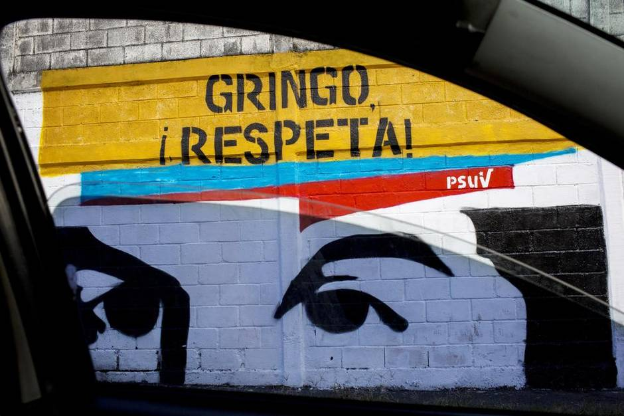
In the wake of a recent announcement of U.S. sanctions against Venezuelan officials murals sprang up around Caracas reading, ‘Gringo, Respeta!’ (Natalie Keyssar for The Globe and Mail)
Venezuela’s shrinking oil output has been Canada’s gain. PDVSA has withered to such a degree that its Citgo refinery outside Chicago is now among the largest buyers of oil-sands crude. And Canadian pipeline giant TransCanada Corp. has pointed to that trend in order to bolster support in the U.S. for its stalled Keystone XL project, insisting that the Alberta-to-Texas pipeline would offset dwindling Latin American imports to the key Gulf Coast market.
The Canadian energy push comes amid an escalating diplomatic spat between Washington and Caracas, and as the U.S. government seeks to rebuild ties with Cuba after years of enmity. The White House this month declared Venezuela a threat to national security, and ordered sanctions on seven officials with ties to President Maduro’s government, citing concerns over human-rights violations. The move came after Venezuela gave the U.S. Embassy in Caracas 15 days to reduce its staff to 17 from 100. Venezuela has also placed visa restrictions on U.S. citizens travelling to the country.
In 2008, the Assembly of First Nations sought to form a “strategic” alliance with Venezuela as part of a campaign to get the government of Stephen Harper to sign the UN Declaration on the Rights of Indigenous Peoples. But a hoped-for visit from Mr. Chavez never materialized. Today, relations between the two countries are largely dormant.
In February, Canadian Foreign Affairs Minister Rob Nicholson expressed concern over a decision by the Venezuelan government to authorize the use of lethal force against protesters, a largely symbolic move.
Violence on the rise
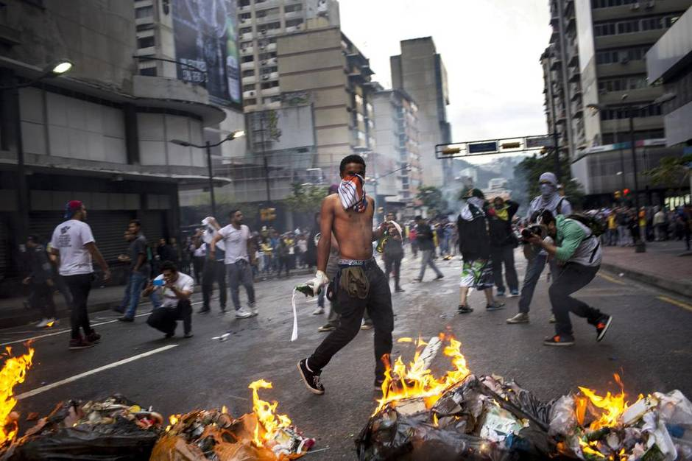
Protesters burn barricades and hurl Molotov cocktails in Chacao on the anniversary of the start of last year’s protests. (Natalie Keyssar for The Globe and Mail)
The bodies arrive in rickety cargo vans; some of those vehicles are held together by tape.
It is Monday at the morgue in the Caracas neighbourhood of Bello Monte. The morgue was once a social club, owned by one of Venezuela’s largest distillers. Fans on the building’s air conditioners sit motionless in the dry morning heat. A pungent stench lingers between parked cars, and wafts over families who seek the shade of nearby jabillo trees.
“The most beautiful crown is the one that justice gives,” a nearby plaque proclaims. It rests near a bronze bust of Simon Bolivar, whose image rivals that of Chavez as a propaganda tool.
For many, it is a hollow sentiment. Officially, Venezuela’s murder rate sits at 39 per 100,000 inhabitants. But convictions are rare, and the government is widely suspected of massaging data, when it reports figures at all. “They don’t exist,” says Sandra Guerrero, who has documented the bloodshed for 20 years as a crime reporter for El Nacional, one of the last vestiges here of a free press. “There’s no official numbers.”
Outside estimates paint a grim portrait. Last year, the widely tracked Venezuelan Observatory of Violence counted 24,980 violent deaths, and pegged the murder rate at a “conservative” 82 per 100,000 inhabitants – up from 79 murders per 100,000 in 2013, and among the highest in South America. (In Canada, there are 1.44 homicides per 100,000 inhabitants.)
As did his predecessor, President Maduro has accused critics of inflating numbers to stoke fear. But data from the UN Office on Drugs and Crime (UNODC) show Venezuela’s murder rate accelerating markedly over the past decade – even as violence in neighbouring Brazil and Colombia has eased – roughly doubling from 2000 to 2012.
Much of the violence is linked to the vast quantities of cocaine, heroin and marijuana that regularly pass through Venezuela from Columbia on their way to markets in North America and Europe. Latin American experts and critics of the government also blame widespread impunity and corrupt policing for perpetuating violence between rival gangs.
Amnesty International this week said it was concerned about political interference in the justice system, as well as an escalation in arbitrary detentions and state-sponsored violence, more than one year after clashes between police and largely middle-class anti-government protesters left 43 people dead.
In February, a 14-year-old student was shot dead by police during a protest in the western city of San Cristobal, triggering another wave of demonstrations. The incident came mere weeks after the government passed a new law authorizing the use of deadly force against demonstrators.
The widespread lawlessness feeds paranoia in the capital, where 3.5 million people live. In Caracas’s superrich enclaves, diplomats and government officials live in walled compounds topped with razor wire. In many areas, locals rarely venture out past 8 p.m. for fear of being mugged or kidnapped. Drivers are regularly robbed at gunpoint in the city’s stifling traffic, and so car windows are tinted deep black to hide the telltale glow of iPhones and other valuable gadgets.
“Every day you can see how people get killed from 10 or 20 shots,” says Ms. Guerrero, the journalist. “When there’s a lot of bodies, they don’t have enough time in one day to do all the autopsies.”
Democracy at risk
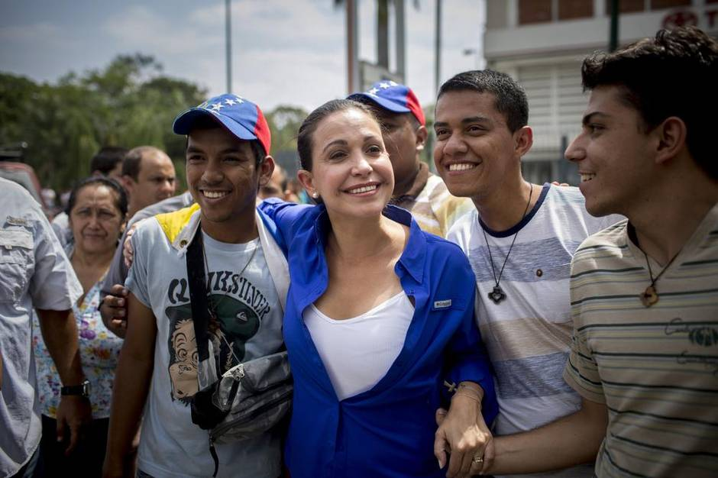
Opposition politician Maria Corina Machado poses for a photo with supporters at a protest last month marking the year anniversary of the first major anti-government demonstration. (Natalie Keyssar for The Globe and Mail)
They came in full riot gear, armed with assault rifles.
In a matter of minutes one day last month, soldiers from the Servicio Bolivariano de Inteligencia Nacional, Venezuela’s secret service, smashed a door with a battering ram at suite 606 in an office in Caracas’s tony Chacao neighbourhood. They vanished just as quickly, taking Antonio Ledezma, Caracas’s mayor, who now stands accused of plotting a coup against the government.
“They kidnapped him, from this very same office,” Mitzy de Ledezma, his wife, recalls in a small meeting room only slightly larger than the cell that the mayor now occupies at Ramo Verde military prison.
The detention followed the arrest last year of opposition figure Leopoldo Lopez, sparking condemnation from rights groups and the U.S. government.
Some opposition leaders, fearing the government crackdown is a prelude to something more ominous, are pressing for a revolt. “We are facing a true national emergency,” says Maria Corina Machado, a former congresswoman who now leads an upstart right-wing movement called Vente Venezuela.
But others see Mr. Ledezma’s arrest as an attempt to goad protesters into the streets, providing cover for delaying parliamentary elections set for later this year. The opposition remains divided following last year’s deadly clashes. Henrique Capriles, who was narrowly defeated by Mr. Maduro in the 2013 presidential election, has urged caution.
It’s unclear what happens next. No firm date is set for the vote. Meanwhile, U.S. sanctions on several Venezuelan lawmakers appear to have backfired, bolstering support for Mr. Maduro and his governing Socialist Party. On Twitter and state-run television broadcasts, the president has stridently denounced the measures as an attempt to topple his government. This month, citing a nebulous “imperialist” threat, he obtained decree powers from Venezuela’s parliament for the rest of the year, a step the opposition decried as a power grab.
Some fear a repeat of the 1989 revolt called the Caracazo, a wave of looting and protests that swept the country after the government raised prices on some goods to cope with sinking oil revenues. Thousands were killed in a government purge, setting the stage for Mr. Chavez’s botched 1992 coup and, ultimately, his triumph during elections six years later.
Even hard-line leftists are growing nervous. There are “authoritarian risks” with Mr. Maduro in power, says Nicmer Evans, of the faction Socialist Tide. “He has lost the capacity to connect with peoples’ needs, and this generates fear.”
Marco Lina has no time to be afraid. Her days are consumed in an endless search for basic consumer goods. “Maybe at one store I can get soap. At another I can get toilet paper,” the 52-year-old says, pausing outside a Portuguese grocery shop in Caracas’s La Florida neighbourhood.
It’s midafternoon, and a steady trickle of customers is buzzed in and out through a heavily barred door. The store is blocks from the towering headquarters of the national oil company, and has been robbed five times in two years. The owner says he is considering shutting for good. The numbers don’t work, he says. Still, he is optimistic things will change for the better.
Ms. Lina laughs as she hears this and calls back over her shoulder: “Dream on! Dream on!”

