Cuba’s Reward for the Dutiful: Gated Housing
By DAMIEN CAVE FEB. 11, 2014; New York Times
Original Here: Cuba’s Reward for the Dutiful
HAVANA — In the splendid neighborhoods of this dilapidated city, old mansions are being upgraded with imported tile. Businessmen go out for sushi and drive home in plush Audis. Now, hoping to keep up, the government is erecting something special for its own: a housing development called Project Granma, featuring hundreds of comfortable apartments in a gated complex set to have its own movie theater and schools.
“Twenty years ago, what we earned was a good salary,” said Roberto Rodríguez, 51, a longtime Interior Ministry official among the first to move in. “But the world has changed.”
Cuba is in transition. The economic overhauls of the past few years have rattled the established order of class and status, enabling Cubans with small businesses or access to foreign capital to rise above many dutiful Communists. As these new paths to prestige expand, challenging the old system of rewards for obedience, President Raúl Castro is redoubling efforts to elevate the faithful and maintain their loyalty — now and after the Castros are gone.
Project Granma and similar “military cities” around the country are Caribbean-color edifices of reassurance, set aside for the most ardent defenders of Cuba’s 1959 revolution: families tied to the military and the Interior Ministry. With their balconies, air-conditioning and fresh paint, the new apartments are the government’s most public gifts to its middle ranks and a clear sign of Cuba’s new hybrid economy, in which the state must sometimes compete with private enterprise.
The housing is just one example of the military’s expansive role in Mr. Castro’s plan for Cuba, and it illustrates a central conflict in his attempts to open up the economy without dismantling the power structure he and his comrades have been building for more than five decades.
In the short term, analysts and former officers say, he is relying on the military to push through changes and maintain stability as he experiments with economic liberalization. Yet his abiding dedication as a lifelong soldier who was defense minister for 49 years threatens to further entrench an institution that has often undermined changes challenging its favored status.
“Raúl knows the military answer is not the answer, but he also knows that at this time he absolutely needs military loyalty,” said Hal Klepak, a Canadian scholar who closely tracks the Cuban military. “They are the only ones who will follow him if the reform succeeds, or if it fails.”
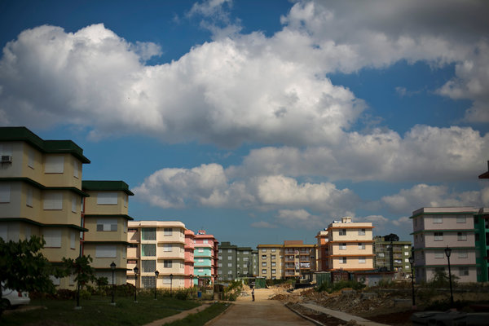
Apartments at a new housing development in Havana called Project Granma are for loyal Communists, families tied to the military and the interior ministry. Todd Heisler/The New York Times
Mr. Castro and his brother, Fidel, given their guerrilla history, have always turned to the military in times of need. In the 1960s and early ‘70s, as Cuba’s professional class fled, officers in fatigues ran government ministries and nationalized industries. Since the 1990s, after the fall of the Soviet Union, the armed forces have been slashed to around 55,000, from a peak of more than 200,000, but they have also been pushed further into the Cuban economy.
As president, Raúl Castro, 82, has accelerated the growth of what some scholars have described as a military oligarchy. The chairman of the Economic Policy Commission, Marino Murillo, is a former officer. Cuba’s largest state conglomerate, Cimex, which processes remittances from Cubans abroad, among other tasks, is run by Col. Héctor Oroza Busutin. Raúl Castro’s son-in-law, Gen. Luis Alberto Rodríguez, is the top executive at the military’s holding company, known as Gaesa, which is estimated to control 20 percent to 40 percent of the Cuban economy.
And its role is expanding. In 2011, a financial arm of the company bought out Telecom Italia’s 27 percent stake in Cuba’s telecommunications company for $706 million. Gaesa also has a network of hundreds of retail stores selling everything from food to appliances. It is a growing force in tourism, too, controlling fleets of luxury buses, a small airline and an expanding list of hotels. And one of its subsidiaries is overseeing the free-trade zone built alongside Cuba’s largest infrastructure project in decades — the new container port in Mariel.
The military’s interests bestow the privileges of business on a chosen few, especially senior military officials. “They live better than almost anyone in Cuba,” said Brian Latell, a former C.I.A. officer who worked in Cuba.
But in the lower and middle ranks, experts say, esteem and relative wealth have eroded. Career officers in Cuba are now more likely to have friends or relatives who live abroad, or who visit Miami and often return with iPhones or new clothes unavailable at the state’s musty stores.
Meanwhile, military members must report all remittances they receive, and they are not allowed any “unauthorized contact” with foreigners or Cubans living abroad — limiting access to the money that other Cubans use not just for purchases, but also to improve their homes and open small businesses.
“It’s producing an exodus of talented people from the state to the private sector,” said Fernando Dámaso, 75, a retired colonel who writes a blog often critical of the government. “Most people in the military have seen their quality of life fall compared to a bartender or someone who has a small business. They can see that they are at a disadvantage.”
The new housing, a basic necessity in extremely short supply across the island, looks to many Cubans like another attempt at favoritism. According to government figures, the military’s construction budget has more than doubled since 2010. When combined with the Interior Ministry (often described as a branch of the military), the armed forces are now Cuba’s second-largest construction entity.
Project Granma — named after the boat Fidel Castro took from Mexico to Cuba to start the revolution — is one of several new military housing developments around the country. Its equivalent in Santiago de Cuba, where the Castro revolution began, has come under fire from Cubans struggling in rickety homes damaged by Hurricane Sandy. But as an attempt to match the private sector, or life in other countries, it is perhaps no accident that the colors and architecture of the Granma, in the same neighborhood that Raúl Castro calls home, give it the feel of a Florida condo complex.
At its edge, there is a baseball field. Inside the gates, streetlamps resembling classic gaslights line the sidewalks, while cars, another perk, fill lots.
At a building with rounded archways, where a movie theater, market and health clinic are meant to go, one of the project’s engineers said several thousand people would eventually call Granma home. Sweating in green army fatigues, he praised the plan, noting its imported, prefabricated design that allowed walls to be assembled quickly, like puzzle pieces. He failed to mention what a security guard had pointed out: Most of the workers painting were prison inmates.
Several residents said they were thrilled to live in what Mario Coyula, Havana’s former director of urbanism and architecture, called “the first gated community in Cuba since the 1950s.” Some said they had been living in cramped quarters with generations of family.
Support for Raúl Castro’s economic changes seemed strong here among those willing to talk. “It’s necessary,” Mr. Rodríguez, the official among the first to arrive at Granma, said as he sat outside with a cigarette. “If you’re cold, you put on a coat; it’s just what makes sense.”
But in the push and pull that has defined Cuba’s economic policies over the last two years, the government has often struggled with when to let the market function and when to protect the Communist establishment. The authorities, for example, recently cracked down on private vendors selling clothes and other items, widely seen as an effort to help the state’s own retail network.
Mr. Dámaso, who spent 32 years in the military, said that the country’s leaders, while longing for economic improvement, mainly want to preserve the Cuba they know.
“If you have a business run by military officers, when there’s a transition, you’re not going to get rid of all these people,” he said. “This is a way to maintain a space for established powers in a future Cuban society.”

